6A^{th} Grade: Unit 6, Lesson 4

- A number line model is shown.
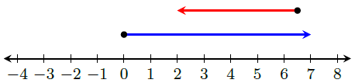
What does the number line represent about the two integers being added?

The longer ray represents a positive number and the shorter ray represents a negative number.

- What expression is represented by the number line model?
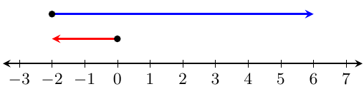

-2 + 8

- Create a number line model that represents the expression -4 + 4.
